1.Pivot element in an array
CODE:
import java.util.*;
public class Pivot{
public static void main(String[] args) {
Scanner s=new Scanner(System.in);
System.out.print("Enter n:");
int n=s.nextInt();
int [] arr=new int[n];
System.out.print("Elements:");
for(int i=0;i<n;i++){
arr[i]=s.nextInt();
}
int tsum=0;
for(int i=0;i<n;i++){
tsum+=arr[i];
}
int lsum=0;
for(int i=0;i<n;i++){
int rsum=tsum-lsum-arr[i];
if(lsum==rsum){
System.out.print(i);
return;
}
lsum+=arr[i];
}
}
}

OUTPUT:
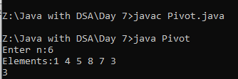
2.ArrayList
CODE:
import java.util.*;
public class Collection1 {
public static void main(String[] args) {
Scanner s=new Scanner(System.in);
ArrayList <Integer> list=new ArrayList<Integer> ();
list.add(5);
list.add(8);
list.add(0);
list.add(2,7);//(index,element)
list.add(1,3);//(index,element)
System.out.println("Elements:" + list);
System.out.println("Array size:" + list.size());
list.remove(1);//index position
System.out.println("After removing the element:" + list);
System.out.println("After removing the element the Array size:" + list.size());
System.out.println("show the element:" + list.get(0));
System.out.println(" Array is emepty:"+list.isEmpty());
list.add(10);
list.add(13);
System.out.println("Elements:" + list);
list.set(1,16);
System.out.println("After update:" + list);
list.remove(Integer.valueOf(3));
System.out.println("is it contains element 7 :"+list.contains(5));
System.out.println("Array size:" + list.size());
list.clear();
System.out.println("Array size:" + list.size());
}
}
OUTPUT:
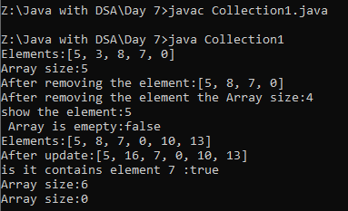
3.Employee program using Arraylist
CODE:
import java.util.*;
public class EmpDetails{
public static void main(String[] args) {
ArrayList<Employee> l=new ArrayList <>();
Employee e=new Employee(101,"Dd","Manager");
l.add(e);
for(Employee x:l){
System.out.println(x.id);
System.out.println(x.name);
System.out.println(x.des);
}
}
}
class Employee{
int id;
String name;
String des;
Employee(int id,String name,String des){
this.id=id;
this.name=name;
this.des=des;
}
}

